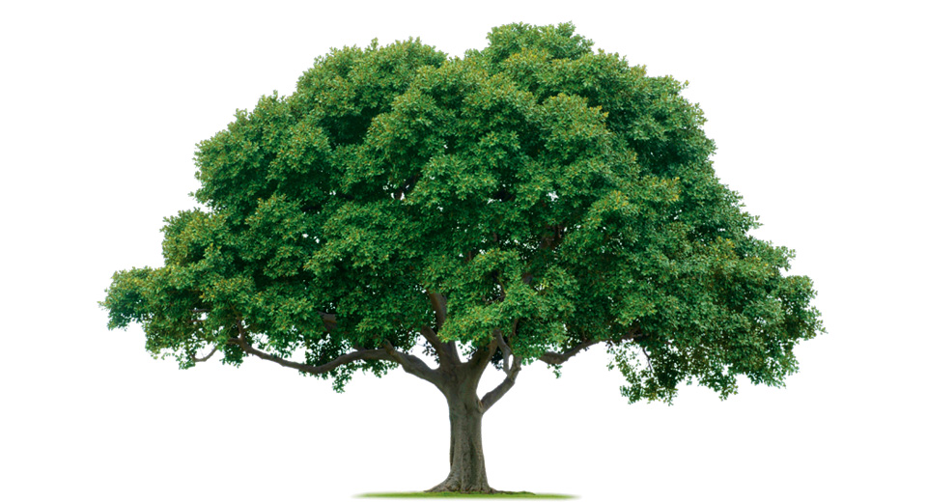

Dear Artists Community,
Our project supported by a grant from the Texas Commission for the Arts.

Call for Artists to participate in an environmental project
http://www.hungarian-multicultural-center.com/id101.html

Juried Art Competition, Dallas, Texas / Budapest, Hungary

Submission Deadline: July 15, 2015

For more info and application form please write to: bszechy@yahoo.com

Artworks Size: 8.5 X 11
All submitted, high-quality art work will be exhibited and tour in Texas and Hungary in 2016. This exhibition is juried and curated by HMC’s Board of Directors.
Media: All media including, but not limited to, Acrylic/Oil, Mixed Media, Pastel, Colored Pencil, Graphics, Water Media or other Layered Media, Photography, and Video Art. No Craft.
About the project:
The new project is to explore solutions to environmental disasters as dying trees, pollution, environmental issues. The project will leverage local and national artists artistic works to generate cross-cultural, cross-border civic engagement in community-led reforestation projects. This exhibition will encourage and support reforestation projects organized in partnership with cultural institutions, like churches and women’s centers. Exhibitions, artist talks dates and places will be organized later for 2016.

About HMC:
Our Mission is to present art that evokes thinking, leads to discovery and inspires creativity by building bridges between people, concepts and entities that have been traditionally considered incompatible. We work to increase the visibility of talented artists from around the world and to foster appreciation of art by teaching people of all ages a 21st century language.

Application Form

First Name Last Name
Address
Phone Email
Website
Nationality

1.title media dimension date
2. title media dimension date
3. title media dimension date
4. title media dimension date
5. title media dimension date

Please pay by PayPal the application fee $10. Simply go to PayPal at www.paypal.com. Login or create an account, then click the "personal" send money tab. Fill in the recipient email: bszechy@yahoo.com. Currency should be US dollars (PayPal will calculate from the current exchange rate). Email subject should be "Environmental Project" and you can add an email message if you'd like. Upon receipt of your PayPal payment, you will receive an email from PayPal and the HMC confirming your payment, which will be matched up with your applications.

